Chapter 10, Solution 55.

Find the Thevenin and Norton equivalent circuits at terminals a-b for each of the circuits in Fig. 10.98.
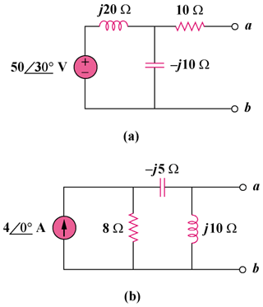

Figure 10.98
For Prob. 10.55.

Solution

- To find , consider the circuit in Fig. (a).

(a)

j20

10

-j10

Z_{th}

22.36-63.43

(b)

j20

10

-j10

5030 V
+

+

V_{th}

To find , consider the circuit in Fig. (b).

50–150 V

2.236–86.6 A

8

Z_{th}

(c)

-j5

j10
- To find , consider the circuit in Fig. (c).

1026

8

(d)

-j5

j10

+

V_{th}

40 A

I_{o}
To obtain , consider the circuit in Fig. (d).

By current division,

33.9258 V

3.39232 A

